AGE ESTIMATION BY GAIT

BY

* Esther Ankomah – 10665054
* Kelvin Obeng Adarkwa – 10665894

**BACKGROUND**

Gait is one of the most common biometrics of behavior and has advantages in terms of being difficult to mimic and obscure compared with other biometric physiological indications. In addition, it can be authenticated at a long distance from a sensor, since it operates without subject cooperation even with fairly low-resolution images.

Accordingly, gait recognition has attracted much attention in many applications. While comprehensive studies on human gait concentrate primarily on hard biometrics, it is also important to consider other attributes, such as gender and age, as they may help improve potential applications such as automated age group consumer counting and gender marketing analysis. Estimating age based on gait is one of the difficult topics; however, it has a high potential for implementation, e.g. automated access control to prevent unauthorized individuals (individuals of unpermitted age) from entering such sites.

In the domain of gait-based age group classification, Davis categorized children (3–5 years old) and adults (30–52 years old), and Begg et al. classed young people (average age 28.4 years and standard deviation 6.4 years) and elderly people (average age 69.2 years as well as standard deviation 5.1 years). Four age groups were classified, that is, children (under the age of 15), adult males, adult females and the elderly (over the age of 65). Chuen et al. categorized children and adults using the OULP dataset, as well as exploring the association between child and adult gait characteristics ( e.g., gait rate, body weight, and head-to-body ratio).

A baseline algorithm using Gaussian process regression (GPR) for gait-based age estimation was presented by Makihara et al., which was applied through a state-of-the-art face-based age estimation. In order to better define and compare the age and gender details of subjects, Lu et al. proposed a multilabel-guided subspace (MLG) and proposed an ordinary preserving multiple analysis method to try a low-dimensional discriminative subspace for tasks of age estimation.

**DATASET**

The dataset was obtained from the Osaka University Large Population (OULP) dataset, owned by The Institute of Scientific and Industrial Research (ISIR), Osaka University (OU). An agreement was signed not to redistribute the dataset; therefore, it will not be included in the project submission. In order to access the dataset, download it from <http://www.am.sanken.osaka-u.ac.jp/BiometricDB/GaitLPAge.html> , sign the agreement and mail it to the administrator to be given the password for the dataset. However, some samples of the dataset which were not password protected were provided and this was included in the project submission and is to be used in running the model to make predictions.

The dataset consists of 63,846 individuals with ages ranging from 2 to 90 years old. 1 Gait Energy Image (GEI) for each individual, a csv file containing the age and gender of each individual, a text file containing the filenames of the images which should be used for training and a text file containing the filenames of the images which should be used for validation were provided. Python scripts were then written to group the data into training and validation sets, and further group into various age groups with age group ID’s ranging from A to I.

Below is a sample of the dataset showing the ages of the individuals:

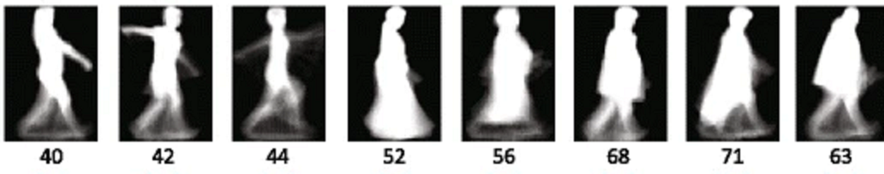

**MODULES**

* numpy==1.16.5
* pandas==0.25.1
* pickleshare==0.7.5
* Pillow==6.2.0
* PySimpleGUI==4.20.0
* scikit-image==0.15.0
* sckit-learn==0.21.3
* scipy==1.1.0

**MODEL**

Random Forest Classifier was used to train the data. The images were loaded from the training and validation folders as numpy arrays with their respective age groups. The images were further refined to remove noise. The images and age groups from the training folder were passed to the model for fitting and the images from the validation folder were passed to the model for prediction. The hyperparameters of the model were tuned to enhance accuracy and easier training. The model is then saved as a pickle file so that it can be used with new data.

**HOW TO USE THE APPLICATION**

1. Open your cmd or terminal and navigate to the AGE-ESTIMATION-BY-GAIT directory.
2. Install all required modules listed under the modules section using pip install [module]==[version]
3. Open the directory with any text editor of your choice. Visual Studio Code was used for development. If your operating system is Linux or Unix, open the config.py file and change every ‘\’ to ‘/’. Do the same for test.py file.
4. Run the command python test.py to start the application.
5. A window will show asking you to select an image to be classified.
6. Click on browse and select an image to be classified.
7. Click on Show Image to display the image selected.
8. Click on Submit to get the estimated age group of the image.
9. A popup window will show with the estimated age group.

**REFERENCES**

Makihara Y, Sagawa R, Mukaigawa Y, Echigo T, Yagi Y (2006) Gait recognition using a view transformation model in the frequency domain In: Proc. of the 9th European Conference on Computer Vision, 151–163. Springer Berlin Heidelberg, Graz.

C. Xu, Y. Makihara, G. Ogi, X. Li, Y. Yagi, and J. Lu, " The OU-ISIR Gait Database Comprising the Large Population Dataset with Age and Performance Evaluation of Age Estimation ", IPSJ Trans. on Computer Vision and Applications, Vol. 9, No. 24, pp.

1-14, Dec. 2017.

Chuen BKY, Connie T, Song OT, Goh M (2015) A preliminary study of gait-based age estimation techniques In: 2015 Asia-Pacific Signal and Information Processing Association Annual Summit and Conference (APSIPA), 800–806. IEEE, Hong Kong.

Begg RK (2005) Support vector machines for automated gait classification. IEEE Trans Biomed Eng 52(5):828–838.

Davis JW (2001) Visual categorization of children and adult walking styles In: Proc. of the Int. Conf. on Audio- and Video-based Biometric Person Authentication, 295–300. Springer Berlin Heidelberg, Halmstad.